Liberate

James Jarrold <http://jamesjarrold.co.uk>

# Controls

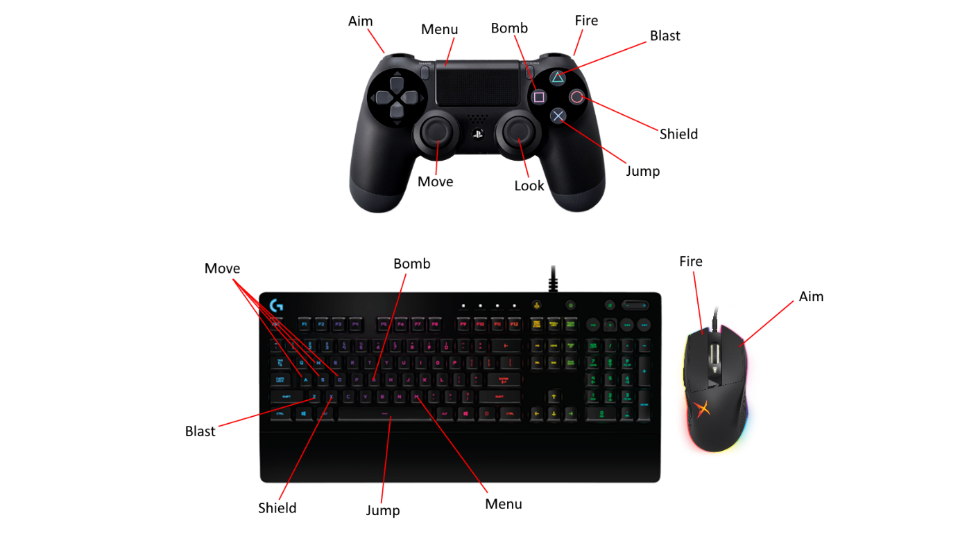

|  |  |  |
| --- | --- | --- |
| Action | PC | Controller |
| Movement | WASD | Left Stick |
| Look | Mouse | Right Stick |
| Jump | Spacebar | X Button |
| Aim Down Sight | Right Mouse Button | L2 |
| Fire Primary Weapon | Left Mouse Button | R2 |
| Bomb Ability | G Key/Third Mouse Button | Square Button |
| Blast Ability | Z Key/Fourth Mouse Button | Triangle Button |
| Shield Ability | X Key/Middle Mouse Button | Circle Button |
| Menu | M Key | Touchpad Button |

# Objectives

* Defeat Enemies
* Clear Regions of Enemies to Gain Skill Points
* Spend Skill Points on Upgrades
* Traverse to New Regions
* Liberate the Whole Planet by Clearing All Regions
* Your Abilities and Attacks use “Energy” which regenerates over time
* Health also regenerates over time and this is the only way to heal
* Energy is represented by the blue bar on the HUD and can be upgraded with skill points
* The lower your energy level, the more damage you take from enemy attacks, so be cautious!

# Features

The world is divided into regions which define the difficulty of the enemies you’ll face, as well as changing environmental features such as forestry or mountainous regions. Your objective is to clear each region by defeating all of the enemies in each area. By clearing a region, you will be awarded with skill points. At any point you can open the menu to view the map, including details for each region of the world and your progress through each. Here you can also travel to the skill tree menu where you will be able to purchase upgrades with the skill points you have collected.